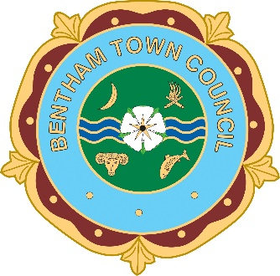
BENTHAM TOWN COUNCIL

Bentham Town Council – Grant Application Form 2027

Financial Year: 2027 - 2028
Application Deadline: Friday 30th October 2026 at 4pm

Please read the Grant Award Policy carefully before completing this form. Incomplete applications or those received after the deadline may not be considered.

SECTION 1 – Organisation Details

1. Name of Organisation:

2. Organisation Address:

3. Contact Name:

4. Position in Organisation:

5. Telephone Number:

6. Email Address:

7. Website / Social Media (if applicable):

8. Legal Status (please tick):
☐ Registered Charity (Charity No: ___________________)
☐ Charitable Incorporated Organisation
☐ Community Group / Association
☐ Club / Society
☐ Other (please specify): ___________________________
(Limited companies are not eligible for funding.)

SECTION 2 – About Your Organisation
9. What are the aims and objectives of your organisation?

10. Who does your organisation serve?

11. Approximately how many residents of the Parish of Bentham benefit from your organisation annually?

SECTION 3 – Project / Activity Details
12. Title of Project / Activity:

13. Detailed Description of the Project / Activity:
(Include what the funding will specifically be used for.)

14. How will this project benefit residents of the Parish of Bentham?

15. Project Start Date: ___________________
16. Project Completion Date: ___________________

SECTION 4 – Financial Information
17. Total Cost of Project: £ ___________________
18. Amount Requested from Bentham Town Council: £ ___________________
19. Please provide a breakdown of project costs:

Item | Cost (£)
Total

20. Matched Funding (if applicable):
Source | Amount (£) | Secured? (Y/N)

For projects over £500, the Council may require up to 50% matched funding.
SECTION 5 – Organisation Finances
21. Total Income (last financial year): £ ___________________
22. Total Expenditure (last financial year): £ ___________________
23. Current Cash Reserves: £ ___________________
24. Please explain why your organisation requires this grant despite any reserves held:

SECTION 6 – Supporting Documentation Checklist
Please enclose:
☐ Copy of previous year’s accounts
☐ Evidence of matched funding (if applicable)
☐ Governing document / constitution (if first-time applicant)
☐ Invoices/quotes included
☐ Any additional supporting material

SECTION 7 – Declaration
I confirm that:
- The information provided in this application is accurate and complete.
- The organisation operates on a not-for-profit basis.
- Any grant awarded will be used solely for the purpose described.
- The organisation agrees to comply with the Council’s Grant Awards Policy.
- A representative will attend the Annual Parish Meeting to collect the grant (or submit a written report with apologies).
- Invoices or quotes have been included.

Signed: _____________________________________

Name (Print): _____________________________________

Position: _____________________________________

Date: _____________________________________

Data Protection Statement
The information provided will be used solely for the purpose of assessing this application and may be disclosed in accordance with the Freedom of Information Act. Details of successful grants will be published on the Council’s website and social media.

Deadline date is Friday 30th October 2026 at 4pm.

Return to the Town Clerk: townclerk@benthamtowncouncil.co.uk

