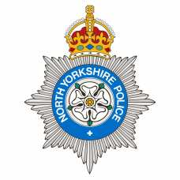

**We asked, You Said, We Did**

Dear Resident,

Bentham Neighbourhood Policing team are dedicated to listening to the views of residents and your input informs our decision making around our area priorities. It would be fantastic if you can spare some time to speak to the team to answer the below questions.

1. What do you like about living here?
2. What concerns do you have about living here?
3. What would you like to see from your local Neighbourhood Policing Team?
4. Is there anything that you would like to tell us about?
5. Are you aware of community messenger?

Officer to discuss details around community messenger and obtain details so can submit.



E-mail [Jayne.grace@northyorkshire.police.uk](mailto:Jayne.grace@northyorkshire.police.uk)